|  |
| --- |
| 新东方在线英语学习 |
| 新概念 1 册 |
| Lesson65-66 |



扫一扫。更多有趣的英语资讯。

# Lesson 65 单词讲解

1. Dad: 爸爸（口语）
2. key: 钥匙

门的钥匙：the key to the door

车的钥匙：the key to the car

书的颜色：the color of the book

张艺谋的电影：ZhangYimou’s movie

1. baby: 婴儿、宝贝

baby- kid(child)-teenager ti nei zhe er

baby, honey, sweetheart…

1. hear: 听见

Listen! Can you hear it? Look! Can you see it?

Look for it! Can you find it?

1. enjoy: 玩的开心

en- 使得

enlarge, endanger(in dei n zhe er), enslave, enjoy…

* 1. 过的愉快、玩的开心

I enjoy my holiday.

* 1. 喜欢

I enjoy the song very much.

1. mum: 妈妈

mom

# Lesson 65 课文讲解

1. You must be home at half past ten. must\can+ be+ 非动词

must这种这种情态动词必须有动词没动词就得补一个be

他能够在这呆很久。

He can be here for a long time.

他们必须 9 点到这。

They must be here at 9:00.

1. 回家：

be home\ get home\ come home\ arrive home…

1. …the key to the front door.

the front door& the back door the key to …

the answer to the question

the exit to the building ai ke c t

the ticket to the movie

1. 年龄的表达：

…years old

…-year - old

19 岁：nineteen years old\ nineteen-year-old

1. Enjoy yourself. 玩的开心啊

Enjoy your holiday. Enjoy your class.

Enjoy your dinner party. 晚宴

Have a nice day.

# Lesson 65 语法讲解

1. 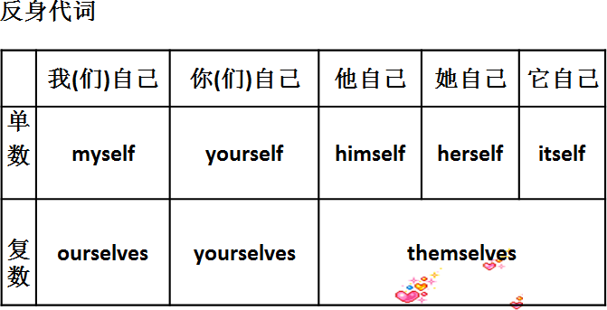英语中为什么有反身代词？
2. 何时用？
   1. 强调主语&宾语

He himself sent me a gift. 他亲自送我一件礼物。

I see WangXiaoya herself. 我见了王小丫本人。

* 1. 不言而喻的宾语

Take good care of yourself. Enjoy yourself.

1. 用法？
2. 介词+ 反身代词

by oneself 独自

I’m going to swim by myself.

He’s going learn English by himself. between oneself 私下

It’s just between ourselves.

1. 动词+ 反身代词

enjoy oneself 玩的开心、过的愉快

They enjoy themselves. help oneself 随 意Help yourselves, please.

# Lesson 66 单词句型讲解

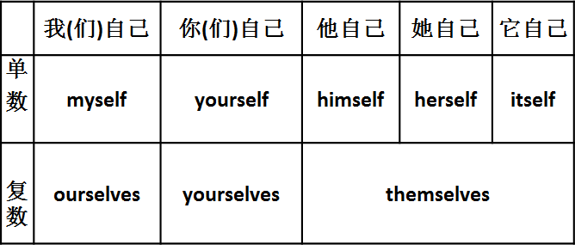

What’s the time? 时间的读法： 3:00: three o’clock

7:30: seven thirty half past seven half to eight

4:20: four twenty

twenty past four forty to five



**past- 过 to- 差**

10:15: ten fifteen

fifteen past ten

a quarter past ten

# a quarter- 15 分钟

2:45: two forty five

forty five past two three quarters past two fifteen to three

a quarter to three

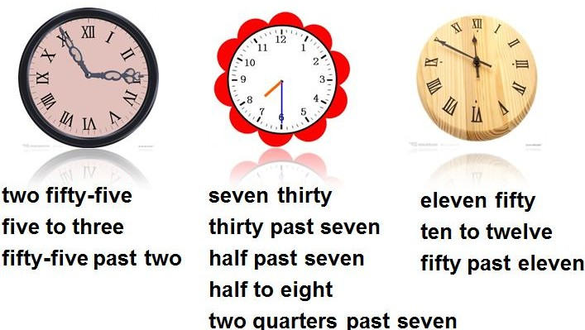

# Lesson 65&66 知识拓展

时间与介词

1. 需加介词的情况：

at+ 点

on+ 天

in+ 月、季、年

1). I’m going to see him ten o’clock. 2). It often rains November.

3). It’s clod winter and hot summer. 4). His birthday is May 1st.

1. She must get up early Monday.
2. I’m going to arrive 10:00 Friday.

